PT Activity: Layer 2 Security
Topology Diagram
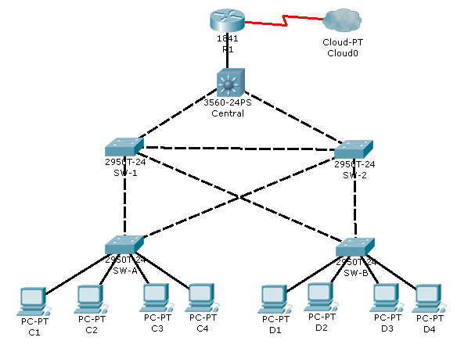
Objectives
- Assign the Central switch as the root bridge.
- Secure spanning-tree parameters to prevent STP manipulation attacks.
- Enable storm control to prevent broadcast storms.
- Enable port security to prevent MAC address table overflow attacks.
Introduction
There have been a number of attacks on the network recently. For this reason, the network administrator has assigned you the task of configuring Layer 2 security.
For optimum performance and security, the administrator would like to ensure that the root bridge is the 3560 Central switch. To prevent against spanning-tree manipulation attacks, the administrator wants to ensure that the STP parameters are secure. In addition, the network administrator would like to enable storm control to prevent broadcast storms. Finally, to prevent against MAC address table overflow attacks, the network administrator has decided to configure port security to limit the number of MAC addresses that can be learned per switch port. If the number of MAC addresses exceeds the set limit, the administrator would like for the port to be shutdown.
All switch devices have been preconfigured with the following:
- Enable password: ciscoenpa55
- Console password: ciscoconpa55
- VTY line password: ciscovtypa55
- Configure Root Bridge
- Determine the current root bridge.
From Central, issue the show spanning-tree command to determine the current root bridge and to see the ports in use and their status.
Which switch is the current root-bridge? Current root is SW-1
Based on the current root-bridge, what is the resulting spanning-tree? (Draw the spanning-tree topology.)
- Assign Central as the primary root bridge.
Using the spanning-tree vlan 1 root primary command, assign the 3560 Central switch as the root bridge.
Central(config)# spanning-tree vlan 1 root primary
- Assign SW-1 as a secondary root bridge.
Assign SW-1 as the secondary root bridge using the spanning-tree vlan 1 root secondary command.
SW-1(config)# spanning-tree vlan 1 root secondary
- Verify the spanning-tree configuration.
Issue the show spanning-tree command to verify that 3560 Central switch is the root bridge.
Which switch is the current root-bridge? Current root is Central
Based on the new root-bridge, what is the resulting spanning-tree? (Draw the spanning-tree topology.)
- Protect Against STP Attacks
Secure the STP parameters to prevent STP manipulation attacks.
- Enable PortFast on all access ports.
PortFast is configured on access ports that connect to a single workstation or server to enable them to become active more quickly. On the connected access ports of the SW-A and SW-B switches, use the spanning-tree portfast command.
SW-A(config)# interface range fastethernet 0/1 - 4
SW-A(config-if-range)# spanning-tree portfast

SW-B(config)# interface range fastethernet 0/1 - 4
SW-B(config-if-range)# spanning-tree portfast
- Enable BPDU guard on all access ports.
BPDU guard is a feature that can help prevent rogue switches and spoofing on access ports. Enable BPDU guard on SW-A and SW-B access ports.
SW-A(config)# interface range fastethernet 0/1 - 4
SW-A(config-if-range)# spanning-tree bpduguard enable

SW-B(config)# interface range fastethernet 0/1 - 4
SW-B(config-if-range)# spanning-tree bpduguard enable

Spanning-tree bpduguard can be enabled on each individual port using the command spanning-tree bpduguard enable, or in global configuration mode with the command spanning-tree portfast bpduguard default. For grading purposes, in this activity please use the spanning-tree bpduguard enable command.
- Enable root guard.
Root guard can be enabled on all ports on a switch that are not root ports. It is best deployed on ports that connect to other non-root switches. Use the show spanning-tree command to determine the location of the root port on each switch.
On switch SW-1, enable root guard on ports Fa0/23 and Fa0/24. On switch SW-2, enable root guard on ports Fa0/23 and Fa0/24.
SW-1(config)# interface fa0/23
SW-1(config-if)# spanning-tree guard root
SW-1(config-if)# interface fa0/24
SW-1(config-if)# spanning-tree guard root

SW-2(config)# interface fa0/23
SW-2(config-if)# spanning-tree guard root
SW-2(config-if)# interface fa0/24
SW-2(config-if)# spanning-tree guard root
- Enable Storm Control
- Enable storm control for broadcasts.
Enable storm control for broadcasts on all ports connecting switches (trunk ports). Set a 50 percent rising suppression level using the storm-control broadcast command. Enable storm-control on interfaces connecting Central, SW-1, and SW-2.
Example:
SW-1(config)# interface gi1/1
SW-1(config-if)# storm-control broadcast level 50
SW-1(config-if)# interface fa0/1
SW-1(config-if)# storm-control broadcast level 50
SW-1(config-if)# interface fa0/23
SW-1(config-if)# storm-control broadcast level 50
SW-1(config-if)# interface fa0/24
SW-1(config-if)# storm-control broadcast level 50

**Repeat on SW-2 (gig1/1, fa0/1, fa0/23, and fa0/24) and Central (gig0/1, gig0/2, fa0/1) connection to other switches
- Verify storm control configuration.
Verify your configuration with the show storm-control broadcast command and the show run command.
- Configure Port Security and Disable Unused Ports
- Configure basic port security on all ports connected to host devices.
This procedure should be performed on all access ports on SW-A and SW-B. Set the maximum number of learned MAC address to 2, allow the MAC address to be learned dynamically, and set the violation to shut-down.
Keep in mind that a switch port must be configured as an access port to enable port security.
Example:
SW-A(config)# interface FastEthernet 0/1
SW-A(config-if)# switchport mode access
SW-A(config-if)# switchport port-security
SW-A(config-if)# switchport port-security maximum 2
SW-A(config-if)# switchport port-security violation shutdown
SW-A(config-if)# switchport port-security mac-address sticky

**Repeat on other ports in SW-A and SW-B
Why would you not want to enable port-security on ports connected to other switches or routers?
Ports connected to other switch devices and routers can, and should, have a multitude of MAC addresses learned for that single port. Limiting the number of MAC addresses that can be learned on these ports can significantly impact network functionality.
- Verify port security.
On SW-A, issue the show port-security interface fa0/1 command to verify that port security has been configured.
- Disable unused ports.
Disable all ports that are currently unused. For efficiency purposes, the Activity Wizard will only grade Fa0/5 and Fa0/6 on SW-A and SW-B.
Example:
SW-A(config)# interface FastEthernet 0/5
SW-A(config-if)# shutdown

**Repeat on other ports on SW-A and SW-B
- Check results.
Your completion percentage should be 100%. Click Check Results to see feedback and verification of which required components have been completed.

